1.OR GATE
module or1 (c,a,b);
output c;
input a,b;
assign c=a|b;
endmodule
Simulation:
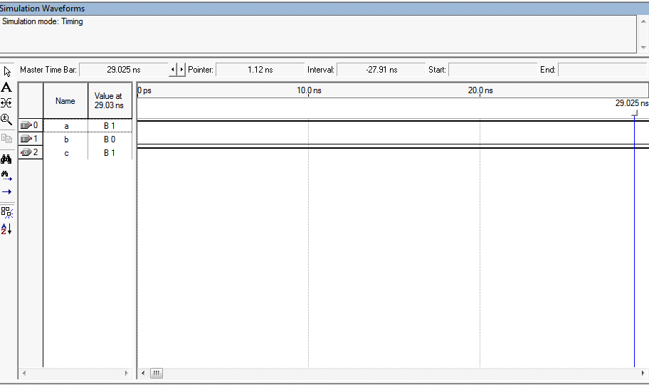

RTL view:

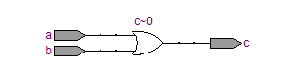

2.AND GATE
module and1(c,a,b);
output c;
input a,b;
assign c=a&b;
endmodule

Simulation:
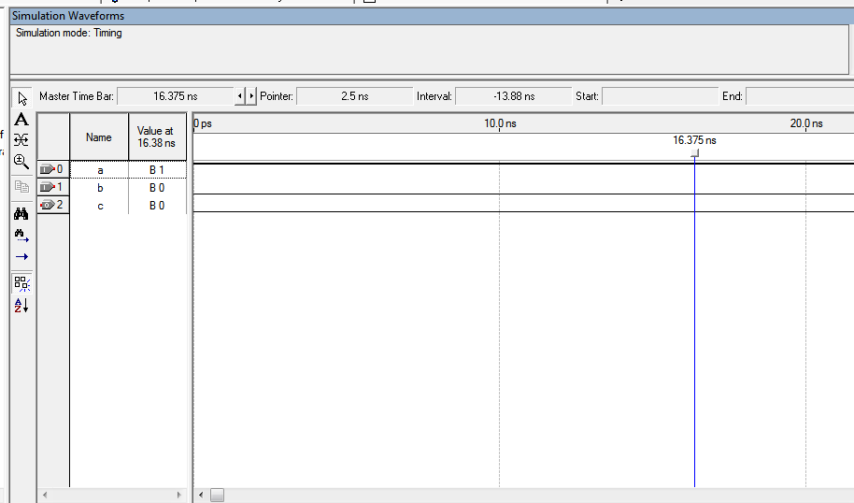

RTL view:
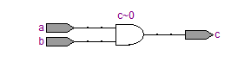

3.NOT GATE
module inv(o,a);
output o;
input a;
assign o=~a;
endmodule

Simulation:
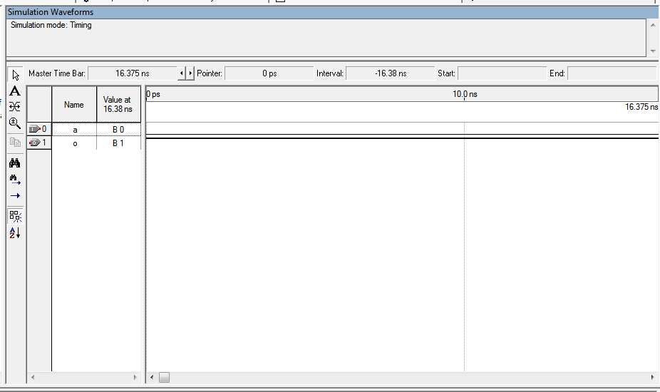

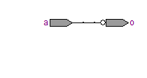

4. NOR GATE
module nor1(c,a,b);
output c;
input a,b;
wire d;
or1 u1(d,a,b);
inv u2(c,d);
endmodule
module or1(c,a,b);
output c;
input a,b;
assign c=a|b;
endmodule
module inv(o,a);
output o;
input a;
assign o=~a;
endmodule

Simulation:
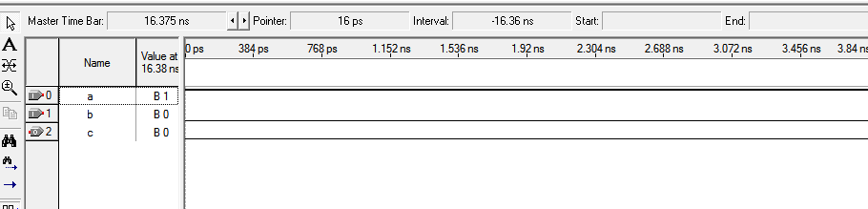

RTL view:
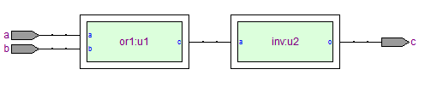
5.NAND GATE
module nand1(c,a,b);
output c;
input a,b;
wire d;
and1 u1(d,a,b);
inv u2(c,d);
endmodule
module and1(c,a,b);
output c;
input a,b;
assign c=a&b;
endmodule
module inv(o,a);
output o;
input a;
assign o=~a;
endmodule

Simulation:

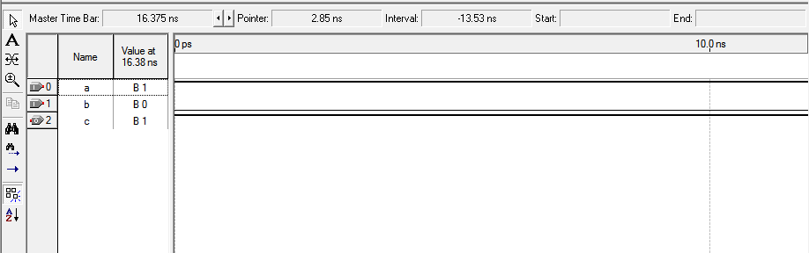
RTL view:
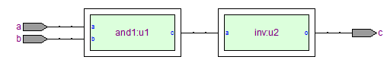
6.EX OR GATE
exor
module exor1(c,a,b);
input a;
input b;
output c;
assign c=(a&~b)|(~a&b);
endmodule

Simulation:
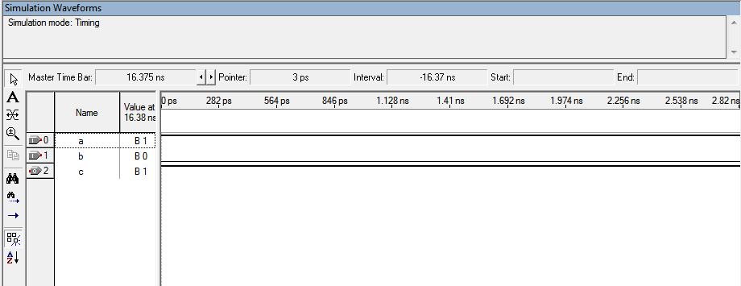
RTL view:
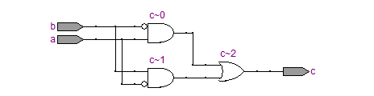

7.EX NOR GATE
module exnor1(c,a,b);
input a;
input b;
output c;
assign c=~((a&~b)|(~a&b));
endmodule

Simulation:
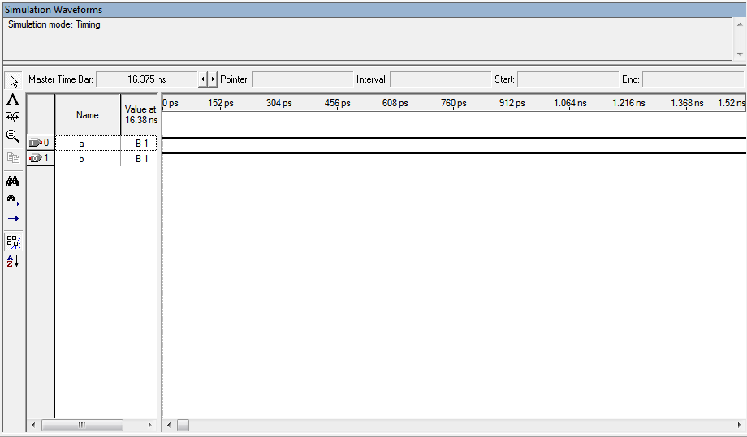

RTL view:
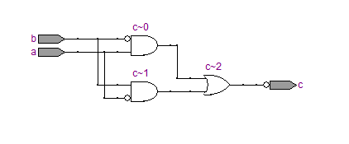

8.BUFFER
module buffer1(o,a);
output o;
input a;
assign o=~(~(a));
endmodule

Simulation:
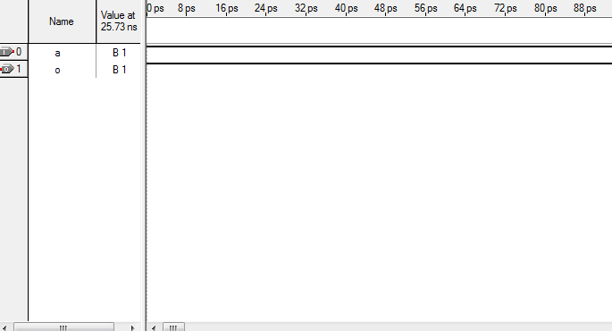

RTL View:
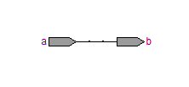

1.HALF ADDER
module half_adder(in_x, in_y, out_sum, out_carry);
input in_x;
input in_y;
output out_sum;
output out_carry;
assign out_sum = in_x^in_y;
assign out_carry = in_x&in_y;
endmodule

Simulation:
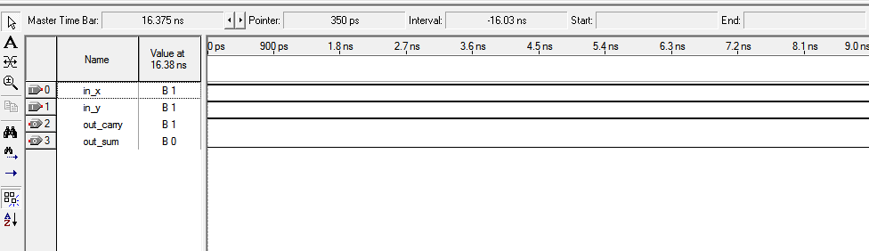

RTL view:
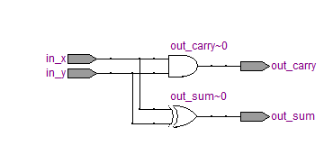
2.FULL ADDER
module fulladder(
input a,
input b,
input cin,
output sum,
output carry );
assign x=a ^ b;
assign sum=x^cin;
assign y=x & cin;
assign z=a & b;
assign carry= y | z;
endmodule

Simulation:
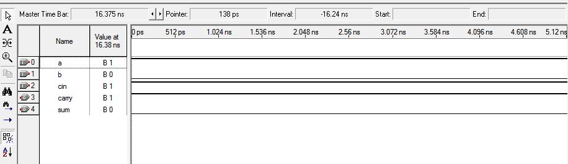

RTL view:
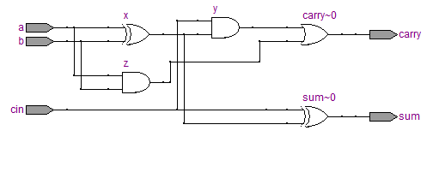
3. 4-BIT MAGNITUDE COMPARATOR
module comparator(a,b,eq,lt,gt);

input [3:0] a,b;
output reg eq,lt,gt;

always @(a,b)
begin
if (a==b)
begin
eq = 1'b1;
lt = 1'b0;
gt = 1'b0;
end
else if (a>b)
begin
eq = 1'b0;
lt = 1'b0;
gt = 1'b1;
end
else
begin
eq = 1'b0;
lt = 1'b1;
gt = 1'b0;
end
end
endmodule

Simulation:
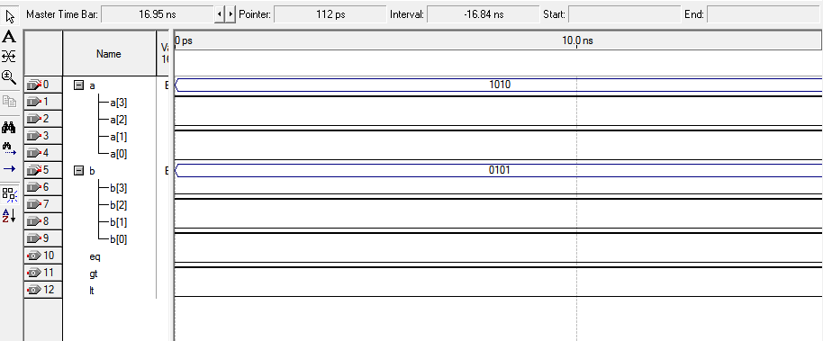

RTL view:
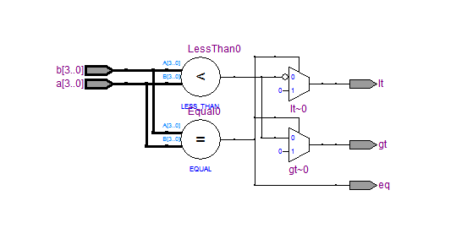

4. 2:4 DECODER
module dec2_4(a,b,en,y0,y1,y2,y3);
input a,b,en;
output y0,y1,y2,y3;
assign y0= (~a) & (~b) & en;
assign y1= (~a) & b & en;
assign y2= a & (~ b) & en;
assign y3= a & b & en;
endmodule

Simulation:
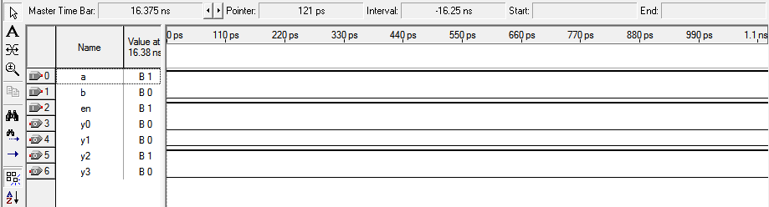
RTL view:
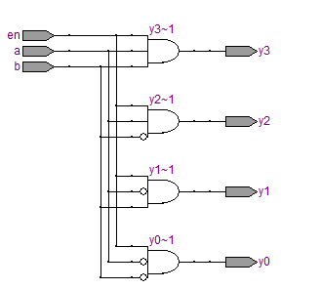

5. 4:2 ENCODER
module encoder4_2 ( a ,b ,c ,d ,x ,y );

output x ;
output y ;

input a ;
input b ;
input c ;
input d ;

assign x = b | d;
assign y = c | d;

endmodule

Simulation:
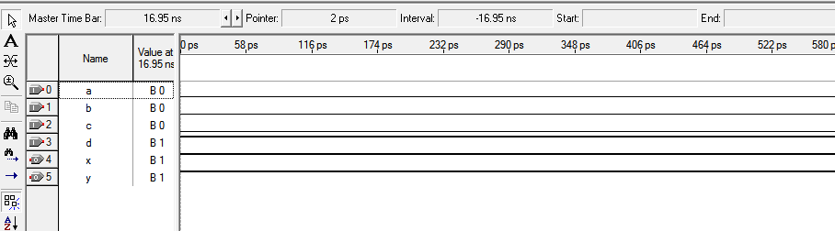
RTL view:
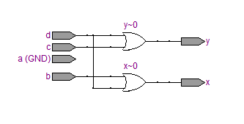
6. 4:1 MUX
module mux4to1 ( input [3:0] a, // 4-bit input called a
input [3:0] b, // 4-bit input called b
input [3:0] c, // 4-bit input called c
input [3:0] d, // 4-bit input called d
input [1:0] sel, // input sel used to select between a,b,c,d
output reg [3:0] out); // 4-bit output based on input sel
// This always block gets executed whenever a/b/c/d/sel changes value
// When that happens, based on value in sel, output is assigned to either a/b/c/d
always @ (a or b or c or d or sel) begin
case (sel)
2'b00 : out <= a;
2'b01 : out <= b;
2'b10 : out <= c;
2'b11 : out <= d;
endcase
end
endmodule

Simulation:
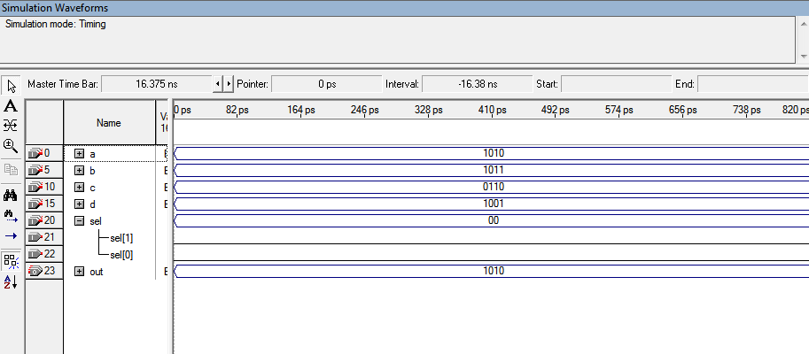
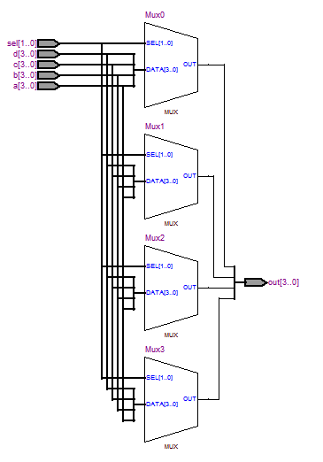
7. 1:4 DEMUX
module demux1_4 ( din ,x ,y ,a ,b ,c ,d );
output a ;
output b ;
output c ;
output d ;
input din ;
input x ;
input y ;
assign a = din & (~x) & (~y);
assign b = din & (~x) & y;
assign c = din & x & (~y);
assign d = din & x & y;
endmodule
Simulation:
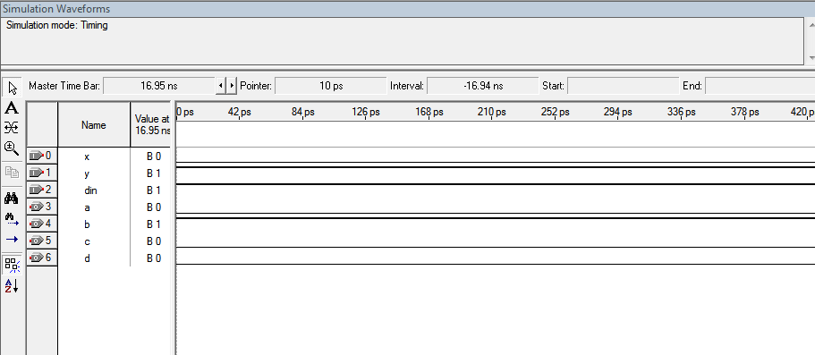
RTL view:
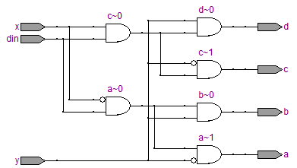

1.D FLIP DLOP
module d(q,q1,d,c);
output q,q1;
input d,c;
reg q,q1;
initial
begin
q=1'b0; q1=1'b1;
end
always @ (posedge c)
begin
q=d;
q1= ~d;
end
endmodule

Simulation:
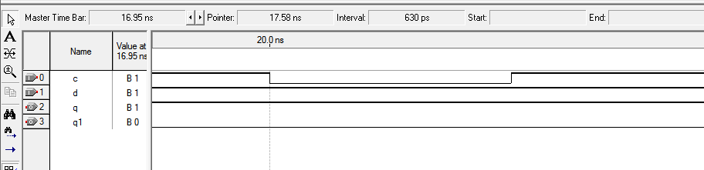
RTL view:
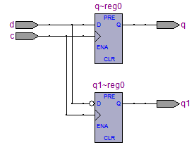
2. JK FLIP FLOP
module jk(q,q1,j,k,c);
output q,q1;
input j,k,c;
reg q,q1;
initial begin q=1'b0; q1=1'b1; end
always @ (posedge c)
begin
case({j,k})
{1'b0,1'b0}:begin q=q; q1=q1; end
{1'b0,1'b1}: begin q=1'b0; q1=1'b1; end
{1'b1,1'b0}:begin q=1'b1; q1=1'b0; end
{1'b1,1'b1}: begin q=~q; q1=~q1; end
endcase
end
endmodule

Simulation:
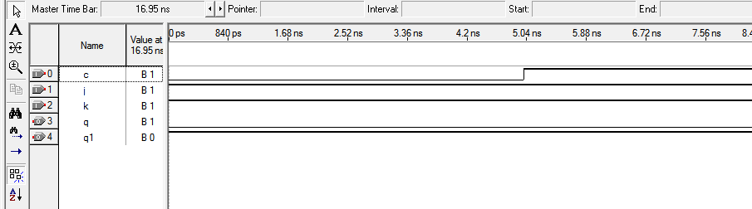
RTL view:
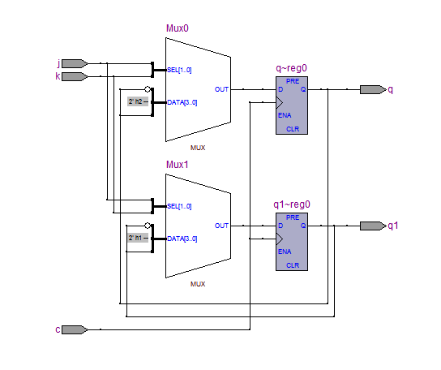
3. T Flip Flop
module TFlipFlop1(q,q1,t,c);
output q,q1;
input t,c;
reg q,q1;
initial
begin
q=1'b0; q1=1'b1;
end
always @ (posedge c)
begin
q = (t&(~q))|((~t)&q);
q1= ~q;
end
endmodule

Simulation:
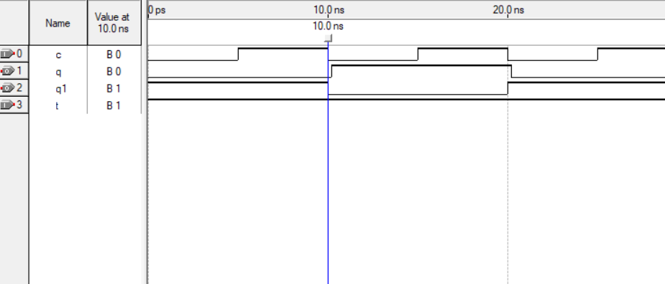
RTL View:
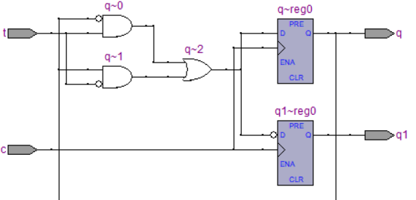
4. SR Flip Flop
module SRFlipFlop1(q,q1,s,r,c);
output q,q1;
input s,r,c;
reg q,q1;
initial
begin
q=1'b0; q1=1'b1;
end
always @ (posedge c)
begin
q = s |( (~r) & q );
q1= ~q;
end
endmodule
Simulation:
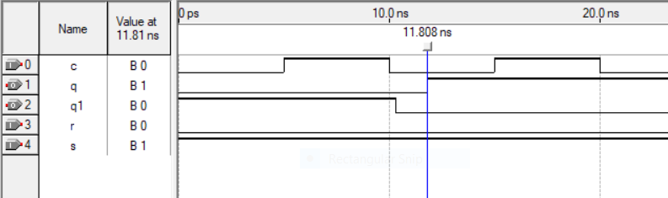
RTL View:
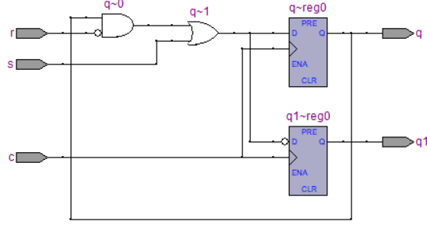
5. 4 Bit Shift Register [SIPO]
module sipo(sout,s1out,sin,clk);
output [3:0]sout,s1out;
input sin,clk;
d u1(sout[0],s1out[0],sin,clk);
d u2(sout[1],s1out[1],sout[0],clk);
d u3(sout[2],s1out[2],sout[1],clk);
d u4(sout[3],s1out[3],sout[2],clk);
endmodule
module d(q,q1,d,c);
output q,q1;
input d,c;
reg q,q1;
initial
begin
q=1'b0; q1=1'b1;
end
always @ (posedge c)
begin
q=d;
q1= ~d;
end
endmodule

Simulation:
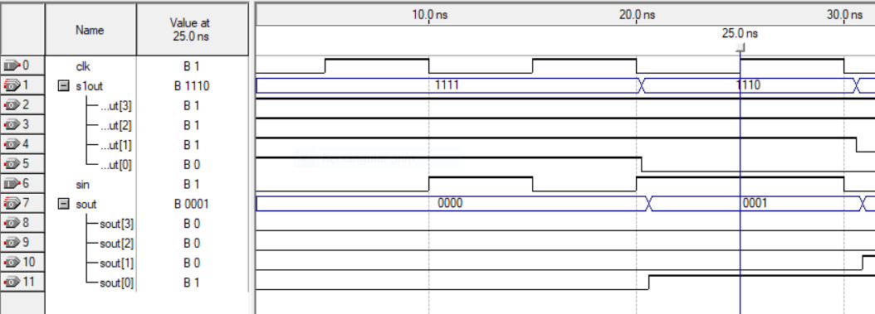
RTL View:
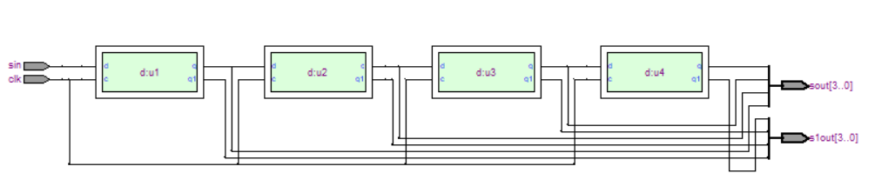

6. 4 Bit Up Counter
module UpCounter(clk, reset, Q);
input clk, reset;
output [3:0] Q;
reg [3:0] Q;
always @ (posedge clk)
begin
if (~reset)
begin
Q <= Q+1;
end
else
Q=0;
end
endmodule
Simulation:
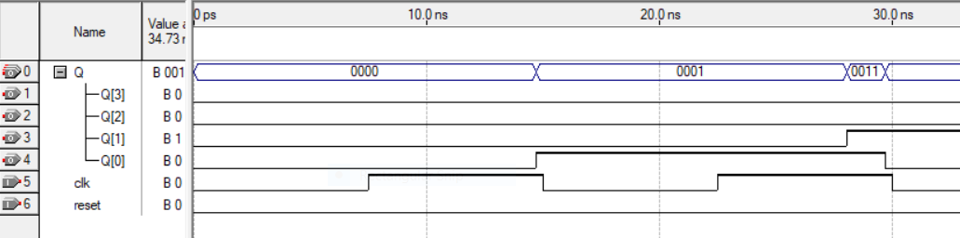

RTL View:
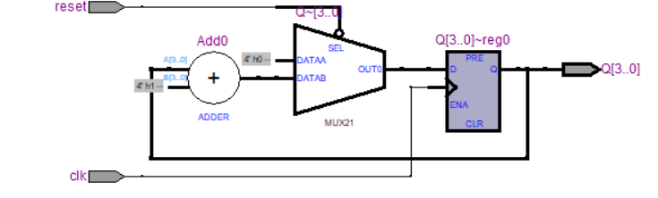
7. 4 Bit Down Counter:
module DownCounter(clk, reset, Q);
input clk, reset;
output [3:0] Q;
reg [3:0] Q;
always @ (posedge clk)

begin
if (~reset)
begin
Q <= Q-1;
end
else
Q <= 15;
end
endmodule

Simulation:
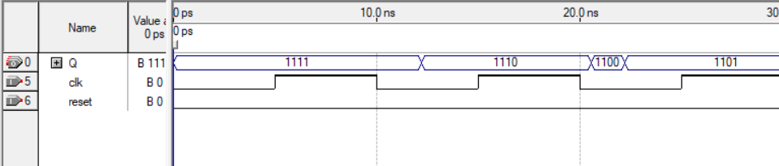

RTL View:
